**LABORATORIES**

The demands of healthcare milieu from modern day nurses have increased manifold. Coordination of patient care, administration of treatment and responding professionally to critical care scenarios, the scope of responsibilities of nurses are on the rise, in response to the advancements in medical care. More than being assistants, nurses are expected to deliver exceptional care to their patients, which in turn requires honed nursing skills, effective communication, critical thinking, and precise clinical judgment, all of which begin to get shaped from the labs at nursing school.

Nursing labs are designed to allow students to practice skills and techniques in safe, controlled, and supervised mock clinical environments. In these labs, students can develop and hone their skills under professorial instruction. Using this model, when the time comes to apply their skills to real patients, students can do so with confidence

At RSM, nursing labs focus on a wide range of nursing skills and knowledge, and the students are not restricted to only one piece of subject matter at any given time. Lab begins with a briefing, which includes the involvement of each student as well as the faculty, who will be administering the lab and overseeing student progress. Guided by these faculties, they can work with their fellow cohort members to apply what they have learned while under a certain level of pressure.

**Nursing Practice Laboratory**

In alignment with the objectives, RSM has nursing practice laboratory designed to provide students with a safe and controlled environment to develop and hone their clinical skills. These labs simulate real-world healthcare settings, allowing students to practice procedures, patient interactions, and decision-making without the immediate pressures of a hospital or clinic. The instructors assist each student on a personalized manner. Resources and equipment foster the enhancement of both student teaching and learning. Clinical skills are not just about the procedural steps, they are developed from a strong knowledge base, a review of relevant references, rehearsal and practice as well as repeated performance and debriefing by faculty.

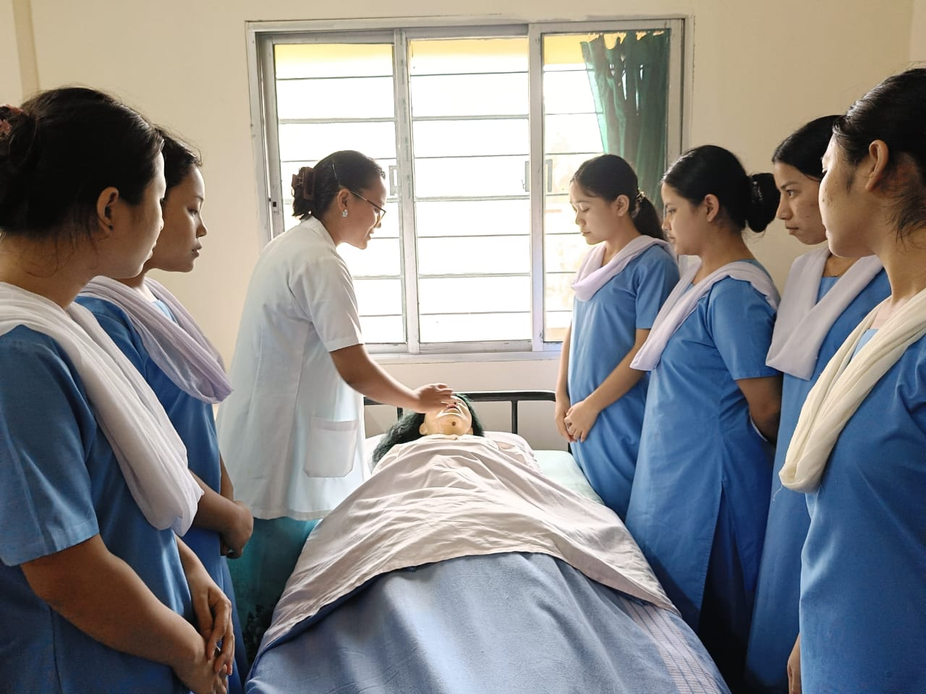

**Pre Clinical Sciences Laboratory**

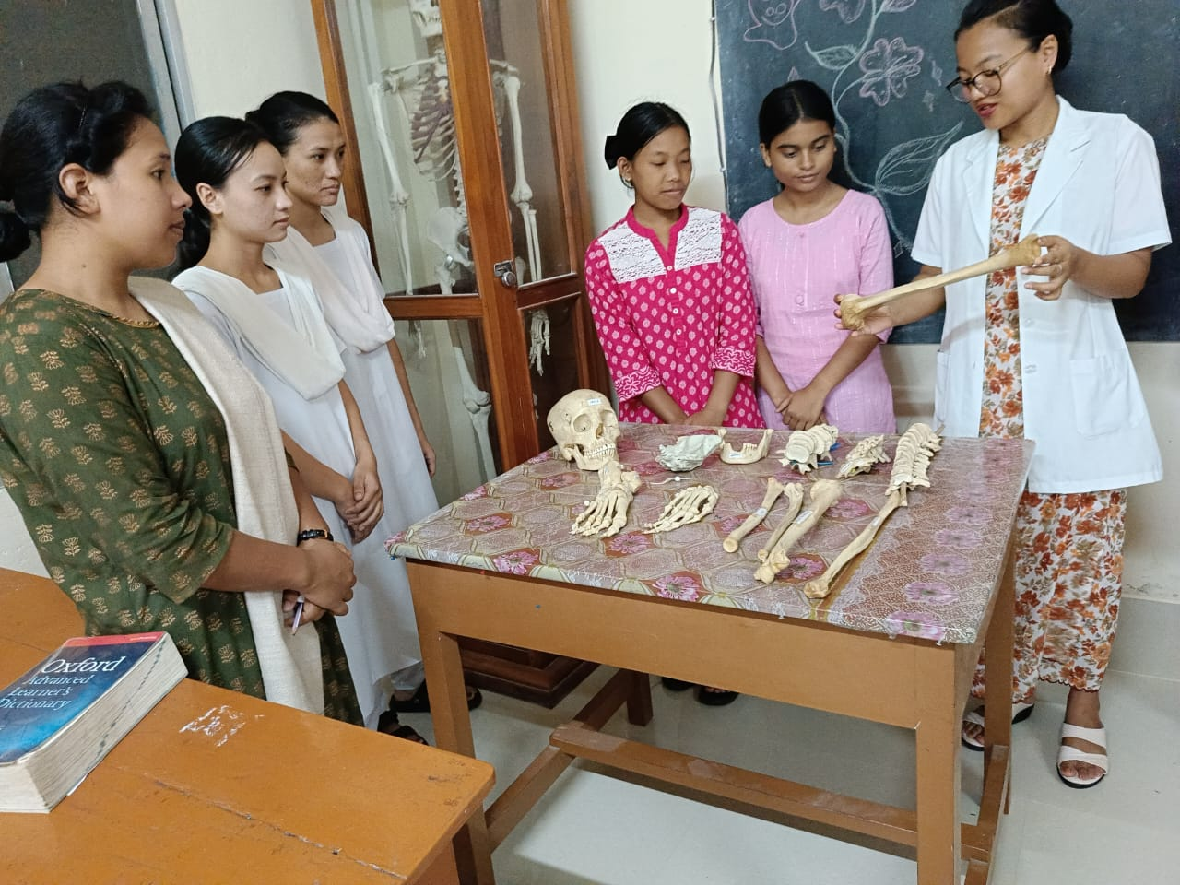

The pre clinical science laboratory is designed with the purpose of helping the students to acquire knowledge of the normal structure and function of various human body systems and to identify any deviation from normal health in order to render effective nursing care.

The school has a well-equipped lab with models, specimens, bones, skeleton, subject related charts etc. The students are encouraged to use the lab to learn Anatomy of bone, joints and other systems. The Physiological processes are also studied by the students before they move on to clinical area.

**Advanced Nursing Skill Lab**

Advance skill lab at RSM provides a structured and supportive learning environment where our students can integrate theoretical knowledge with hands-on clinical skills. The lab prepares the students to encounter the challenges and complexities of nursing by focusing on several key components like clinical competence, skill mastery, patient specific care, continuous learning and reflection. The following objectives are realised in this training environment.

The students develop and enhance basic clinical nursing skills, such as patient assessment, vital sign measurement, and physical examination techniques.

They practice and improve proficiency in various nursing procedures and techniques commonly used in adult health settings.

The activities develop critical thinking skills by engaging them in realistic patient care scenarios.

Encourage students to make clinical judgments, prioritize care, and implement appropriate nursing interventions.

Emphasize the importance of patient safety and infection control measures.

Instruct students on proper techniques for maintaining a sterile environment and preventing healthcare related infections

Train students in safe and accurate medication administration.

Provide opportunities for students to practice dosage calculations and understand medication interactions.

Familiarize students with the use of technology in nursing practice, such as electronic health records, medical devices, and other healthcare technologies.

Foster a sense of professionalism in nursing practice.

Encourage self-reflection and continuous improvement by providing opportunities for students to review and analyze their own performance.

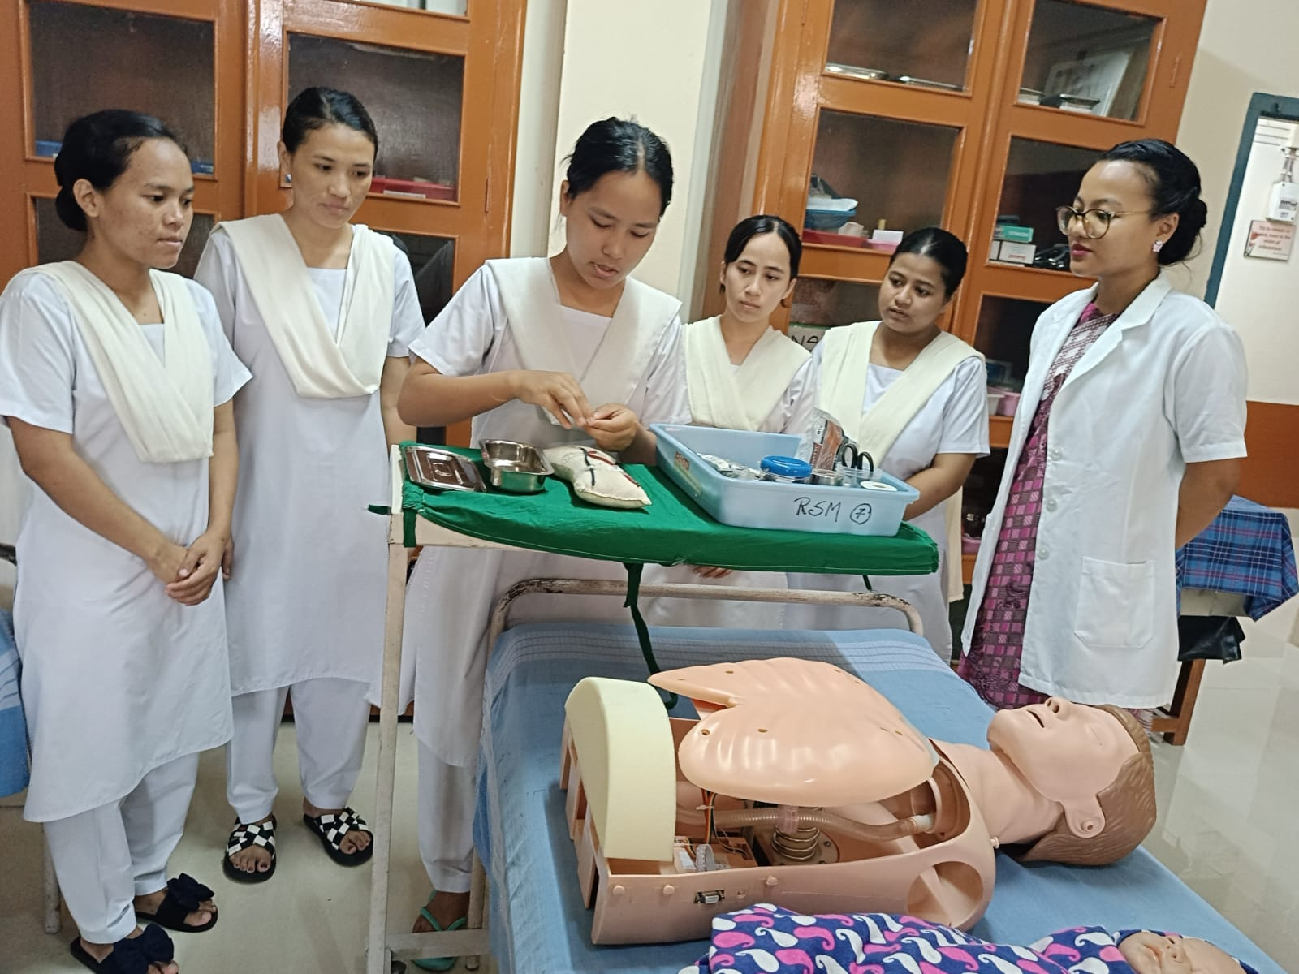



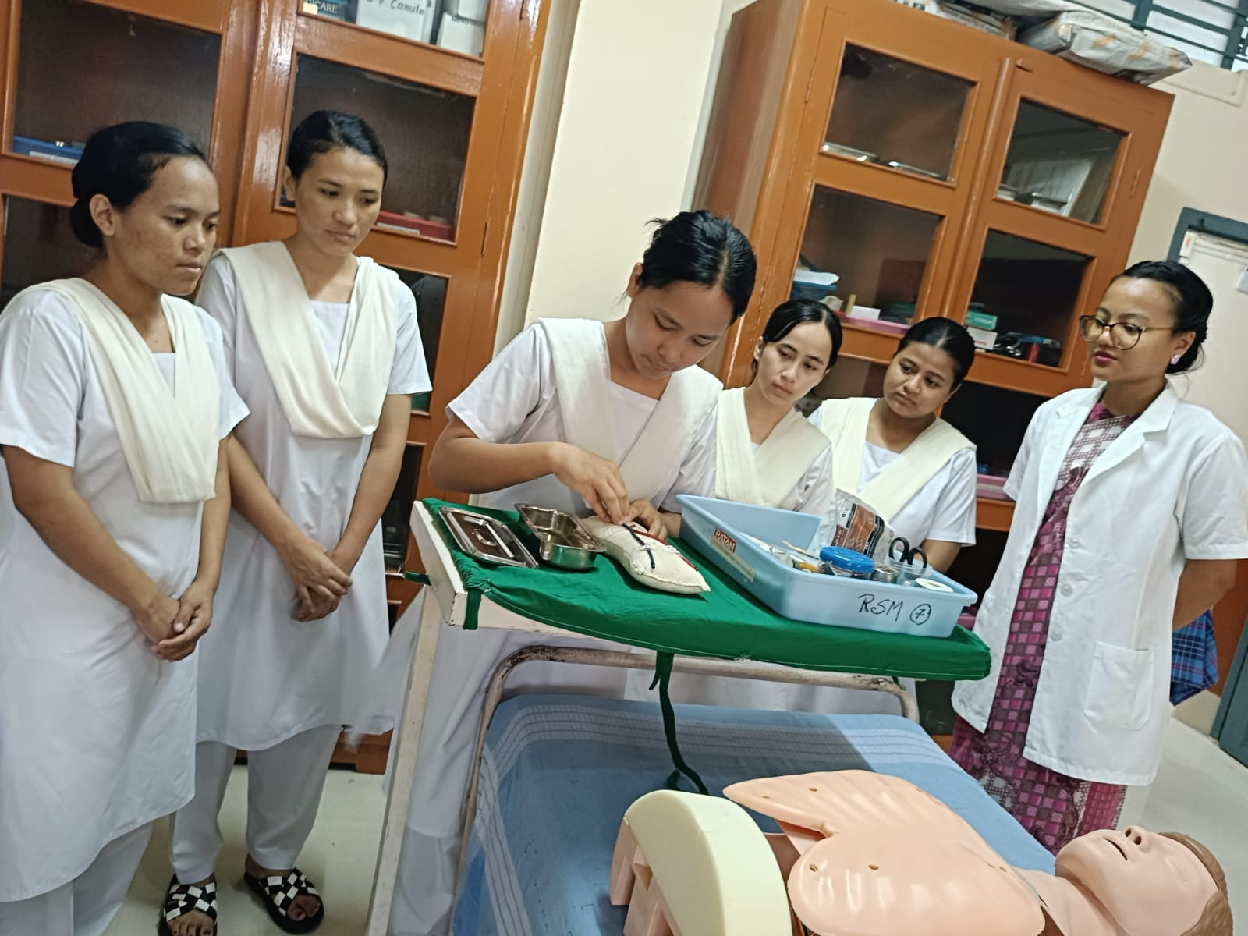

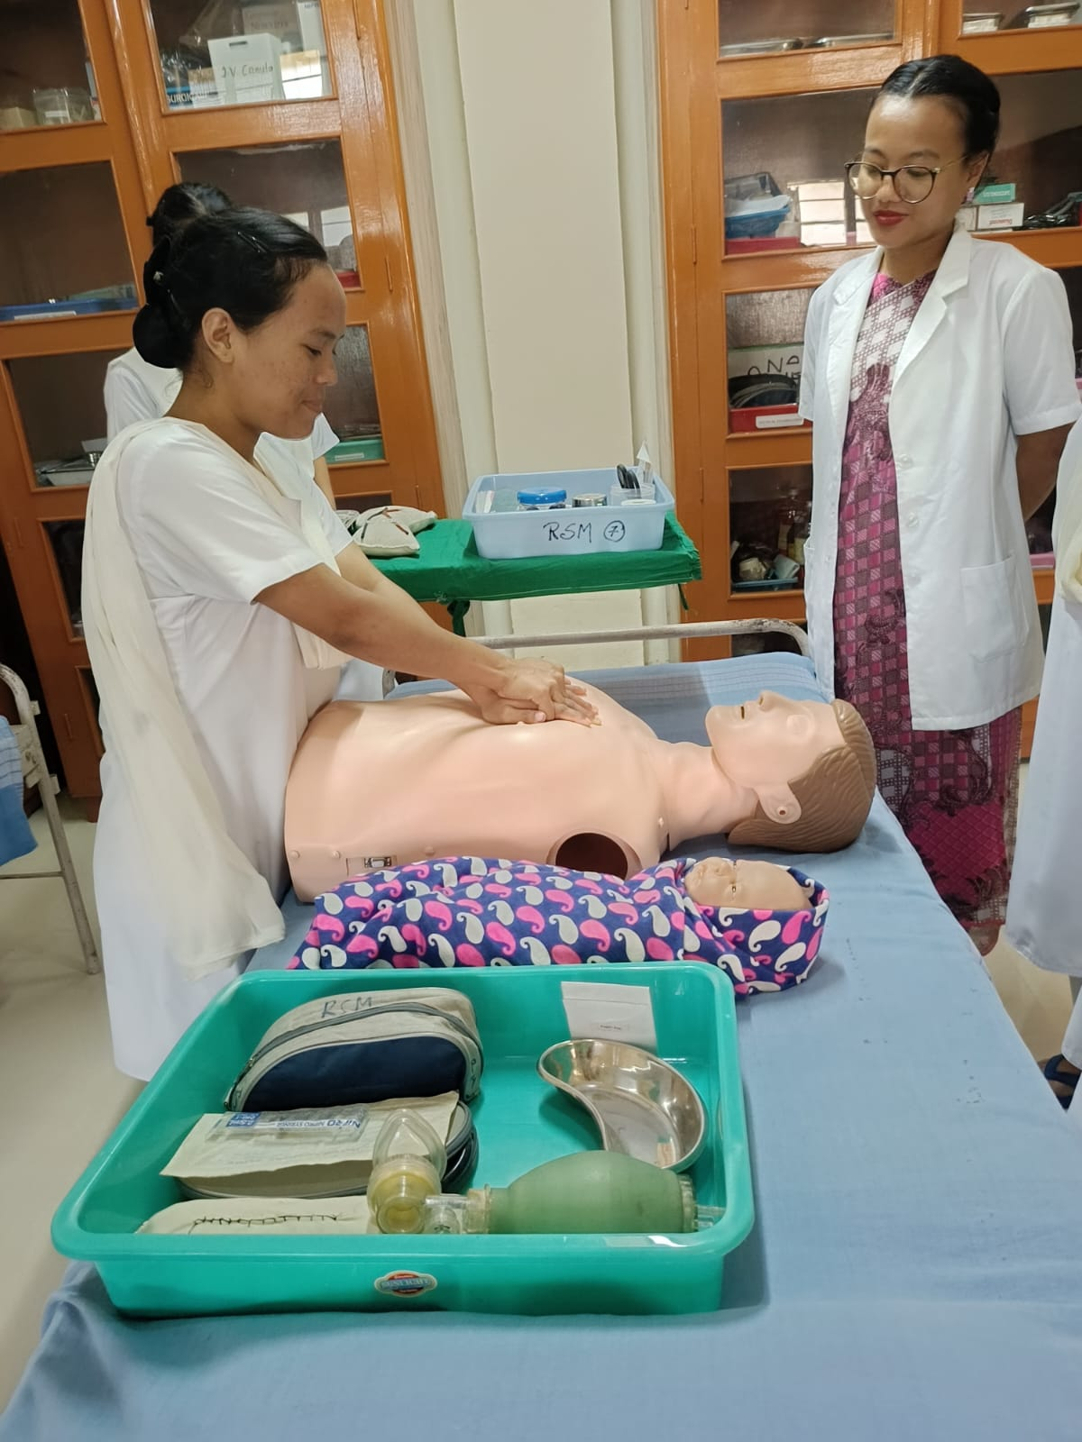

OBSTETRICS AND GYNECOLOGICAL NURSING SKILL LAB

Obstetrics and Gynaecology in nursing is a discipline that shapes the students in the nursing care that should be extended to woman during pregnancy, child birth and postpartum period. The well being of a society has direct correlation to the health and survival of mother and children. A healthy mother gives birth to a healthy infant. Prenatal guidance and efficient care is essential to reduce the maternal mortality and morbidity.

The OBG lab of the school enables the students to practice comprehensive nursing care that are to be extended to mothers and neonates. The lab is equipped with supplies and equipment as well as practice manikins, pregnancy manikin, pelvis, and skull model. The OBG lab ensures effective and efficient services for students to practice and demonstrate competency of selected obstetric skills and neonatal care to be implemented in clinical environment.

The objectives realised during the trainings in OBG lab covers the following areas.

Identify the anatomical parts in the female reproductive system and different stages of foetal development using models.

Perform complete physical assessment for women during the antenatal period

Assess the parturient physical condition and progress of the process of normal labour

Perform complete physical assessment of women during postpartum period and prepare delivery set, instruments and equipment needed during labour

Demonstrate the different foetal positions and presentations and help students to formulate nursing care plans according to each scenario

Perform physical examination and resuscitation for the new born

Assess any deviation from normal during labour

Assess the female genital system to help students dealing with women having any gynaecological problems.

Identify different instruments used for gynaecological women.

Apply universal infection control precautions and safety measures while providing care to the women during antenatal, labour and postpartum, new born, as well as women who have gynaecological problem.

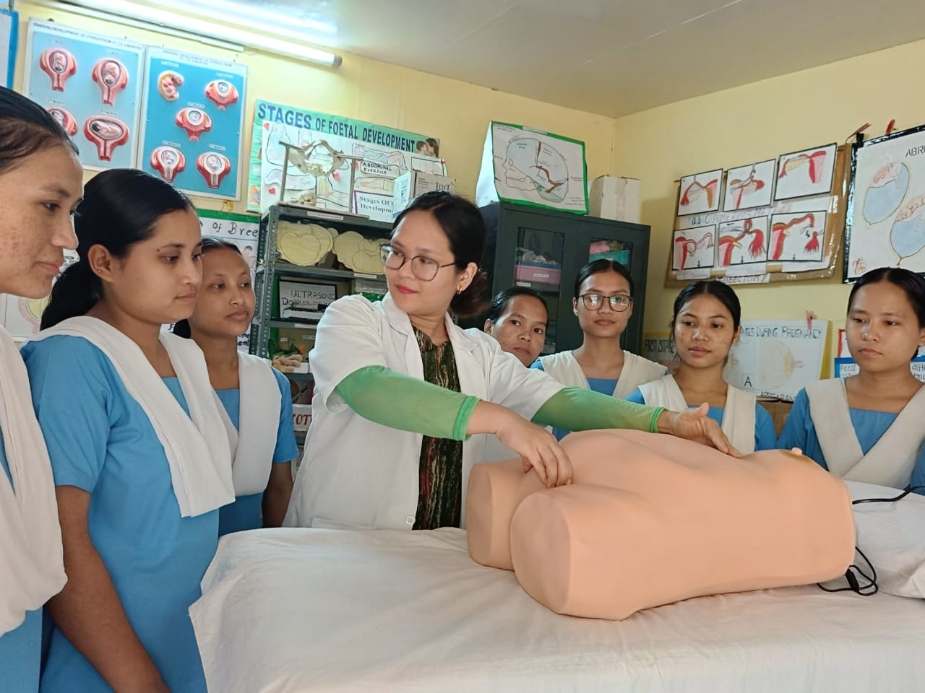

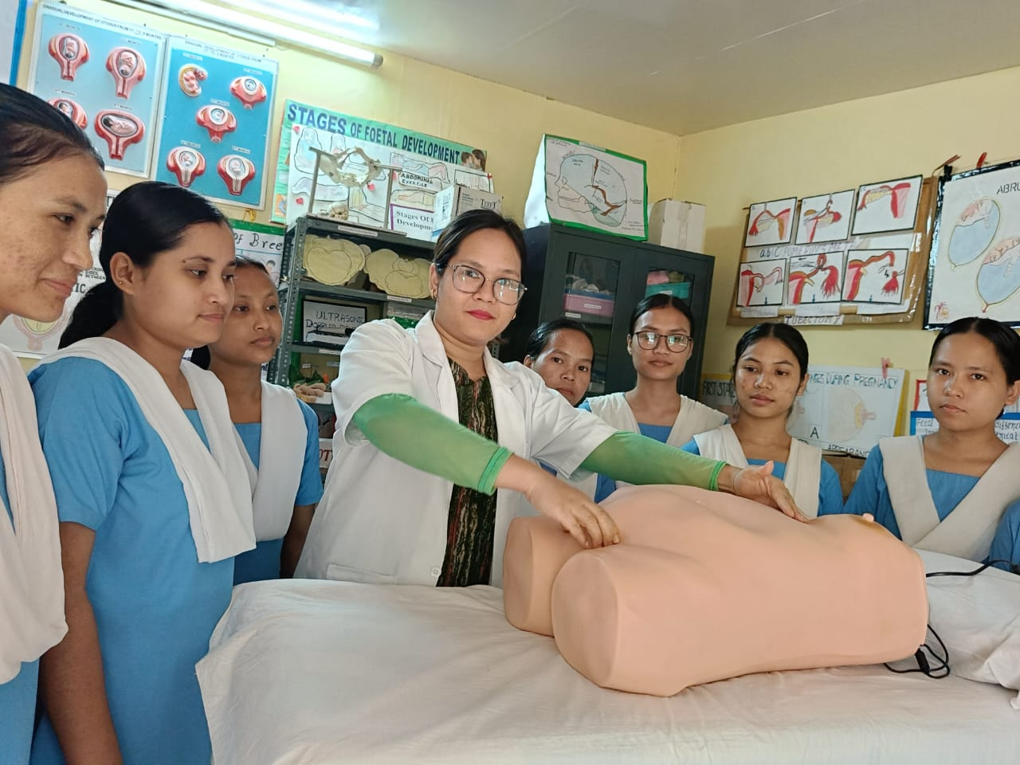

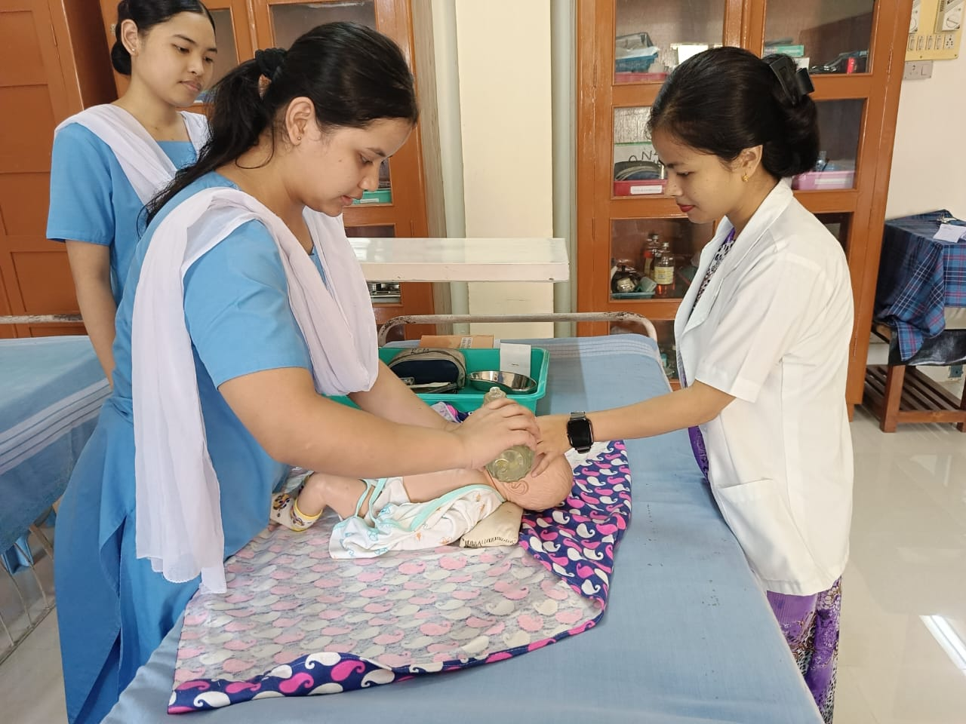



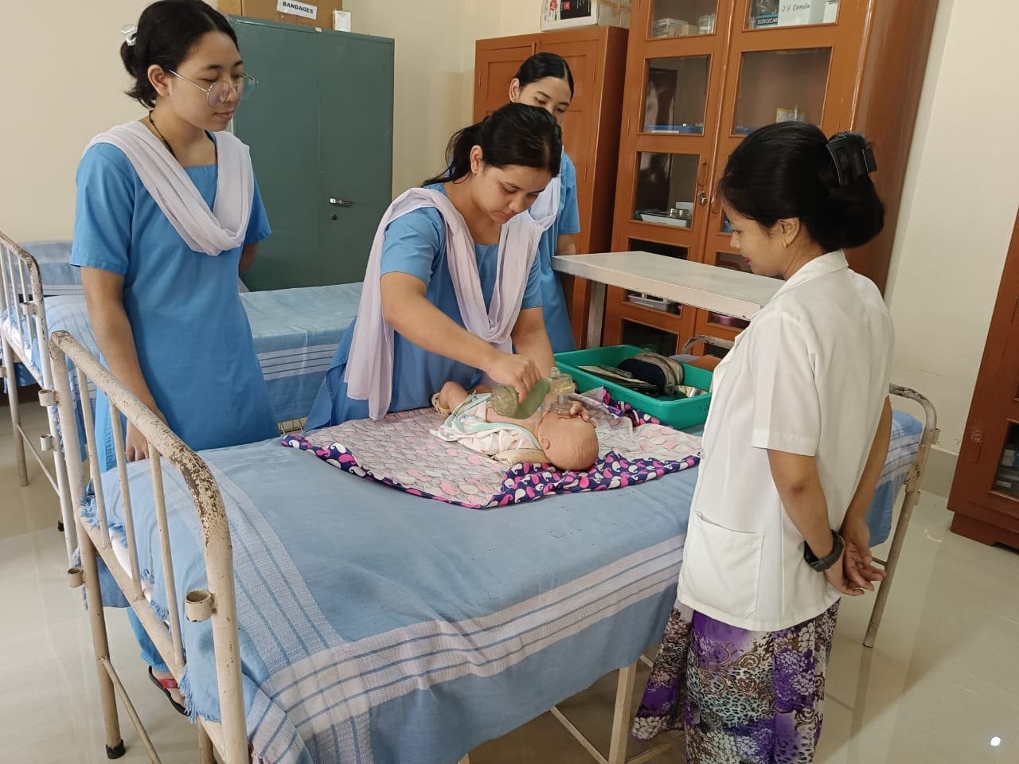



**Community Health Nursing Lab**

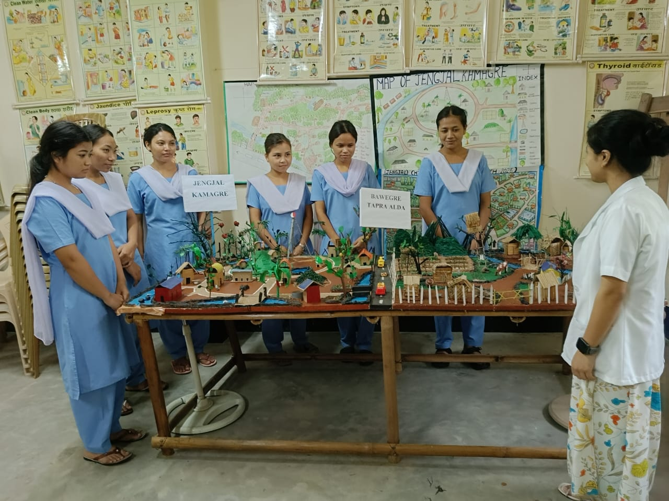

Community Health Lab is an integral part of public health and nursing education. Our community health lab provides students with the knowledge, skills, and experiences necessary to promote health and prevent disease within communities. This lab focuses on understanding the social determinants of health, community assessment, health promotion strategies, and the implementation of community-based health interventions.

**Nutrition Laboratory**

Our Nutrition Lab is designed to provide nursing students with a comprehensive understanding of nutrition and its crucial role in health and disease management. As future healthcare professionals students will be able to understand the basics of nutrition, nutritional assessment, diet planning, nutritional therapy, food safety and regulations and cultural competency in nutrition. The lab is well furnished for the use of varied assortment of cooking methods towards healthy life styles.

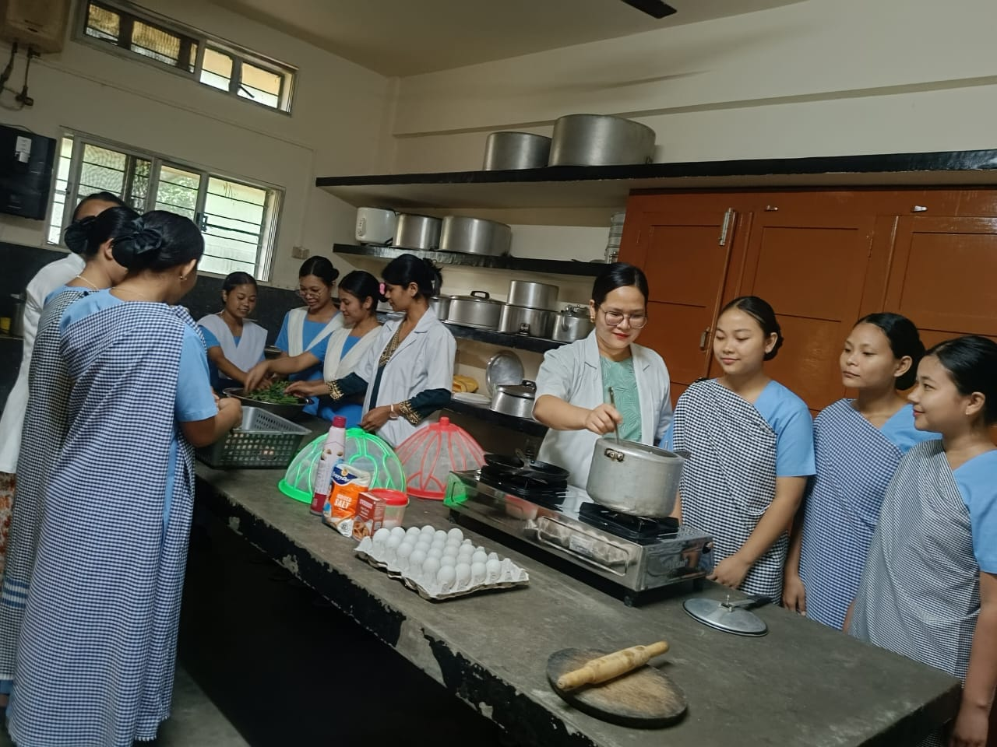

**Computer Laboratory**

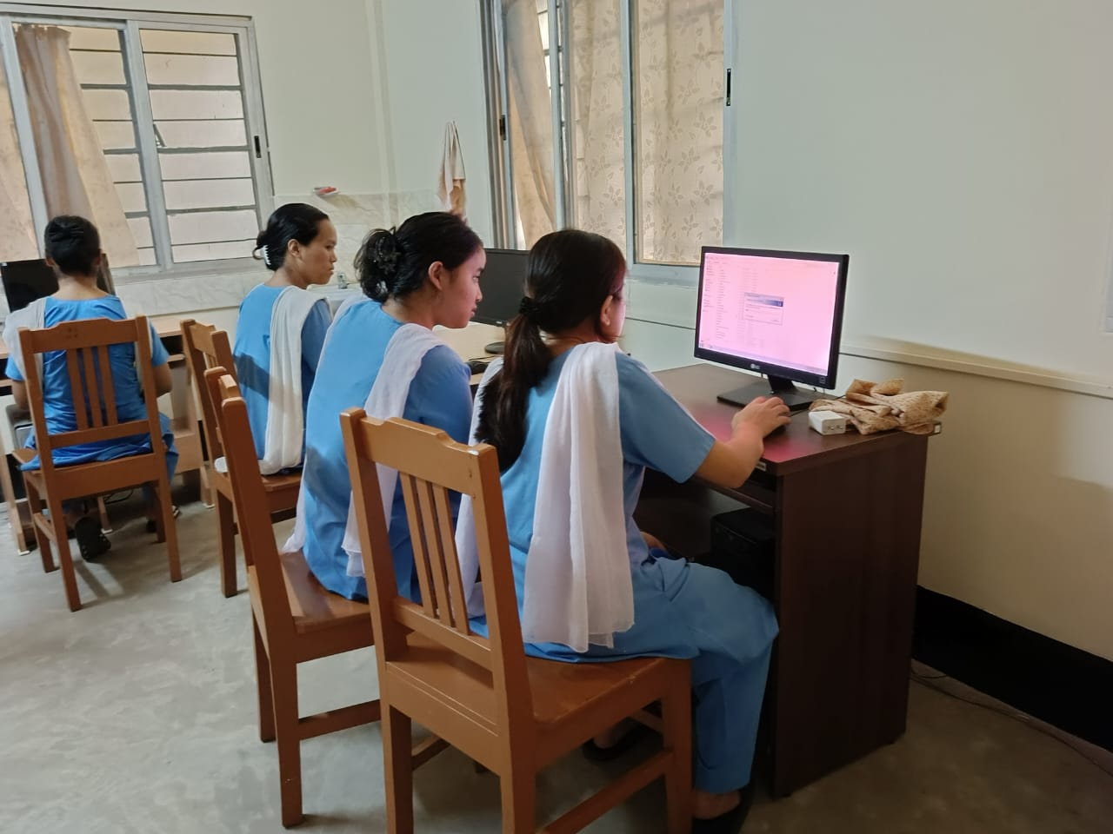

Technological advancement has refined the nursing profession so as to make way for enhanced service in the field of nursing and therefore students are to be trained in the technical aspects of the subject in computer laboratory. The school has a computer laboratory designed to develop the basic understandings of the use of computers and its applications in the field of nursing. Our computer lab is attached to the library and has been equipped with unlimited access to journals and study materials through internet.

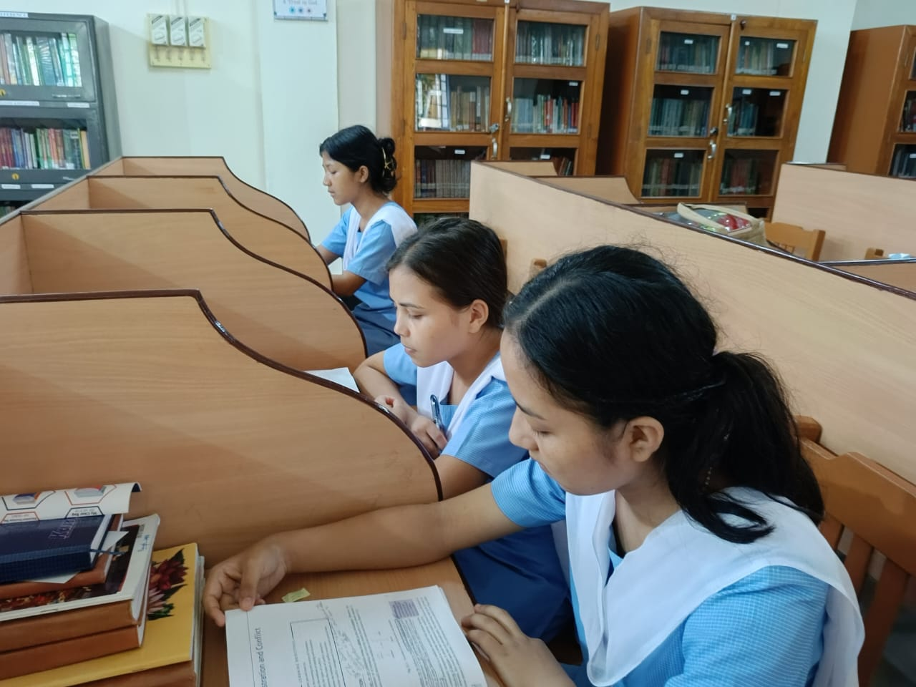

**Library and Reading Room**

There is a, well-ventilated and well-equipped library in the institute maintained by a qualified and experienced librarian. The librarian guides the students in choosing appropriate reading materials. We have an extensive collection of books, journals, and other reading materials that cater to the requirements of the students. It is stocked with everything from anatomy and physiology textbooks to related journals. Internet facility is enabled in the library to enhance academic performance by providing access to a wealth of knowledge and information, enabling students to refine their skills and communication capabilities. Our students spend quality time reading books and gaining knowledge in the library.

**School Mess**

The school mess often a bustling hub of activity, plays a vital role in the daily life of students. It provides not only a place to eat but also a social space where students can relax and interact. High standards of hygiene and food safety are maintained in the mess. This includes regular cleaning, proper food storage, and safe food preparation practices, with adequate seating and a comfortable environment for students to enjoy their meals. The Mess serves both vegetarian and non-vegetarian meals.

The mess is managed by a Mess Committee consisting of the student representatives and teaching staff. The Mess Committee shall respect the opinion of the majority and the final decisions shall be subjected to the consensus of the faculty in charge. The students are inducted to the mess committee on a monthly rotation basis, so as to give opportunity to almost all of them. The student members strictly supervise the activities in the mess at the time of every serving. Cleaning of the mess is also done under their supervision. If found necessary, these members will voluntarily does a final tidying work so as to ensure that the refectory is spick and span.

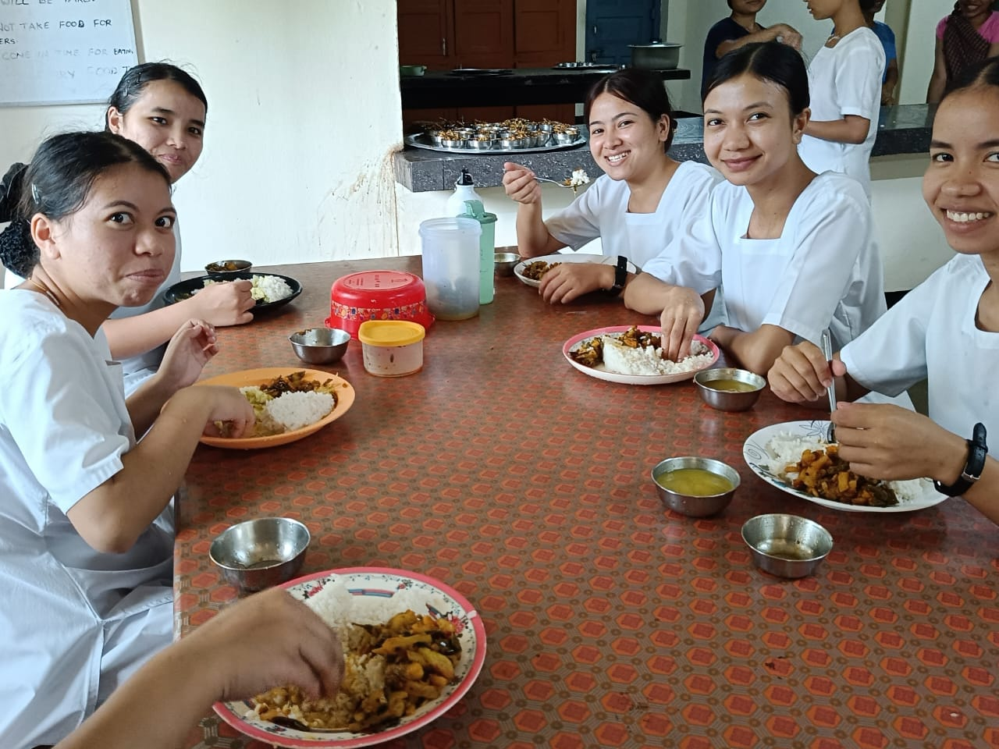

**Transport**

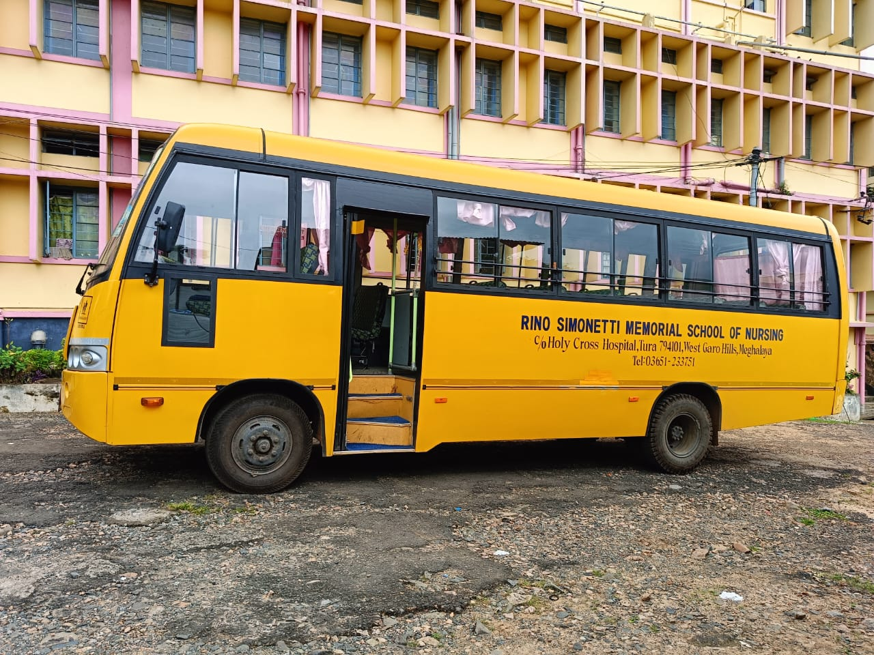

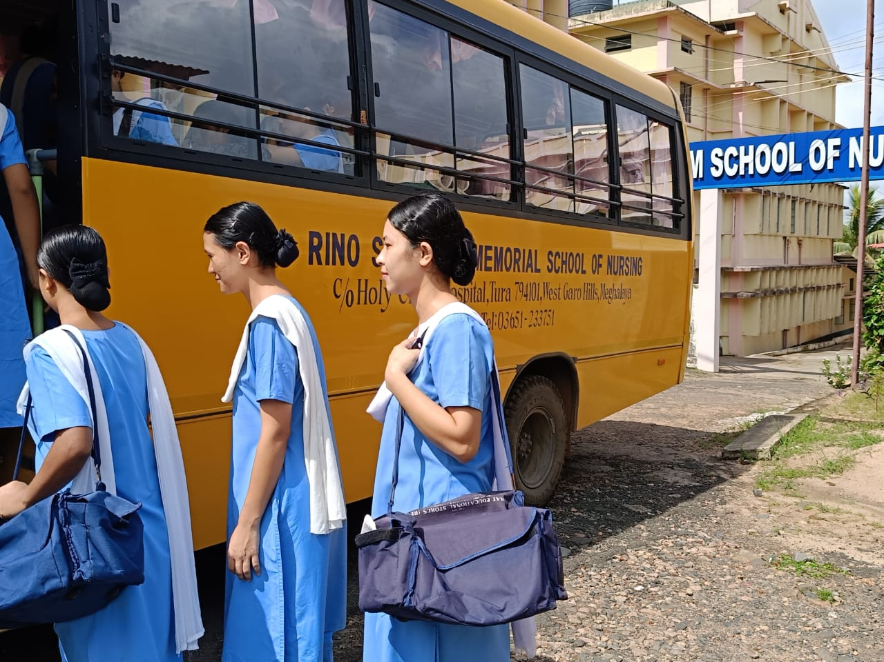

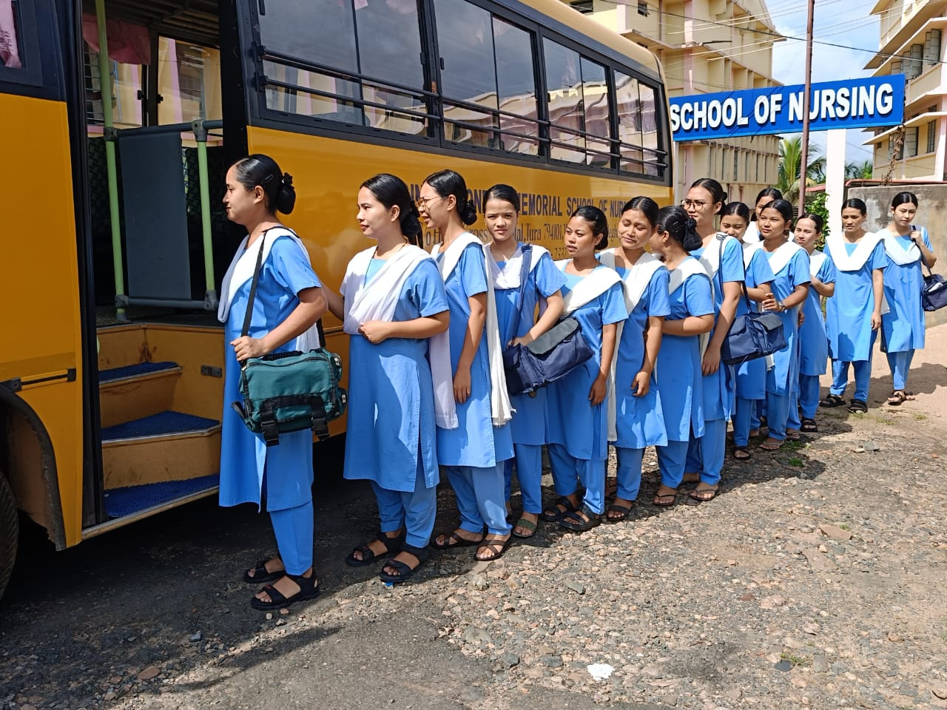

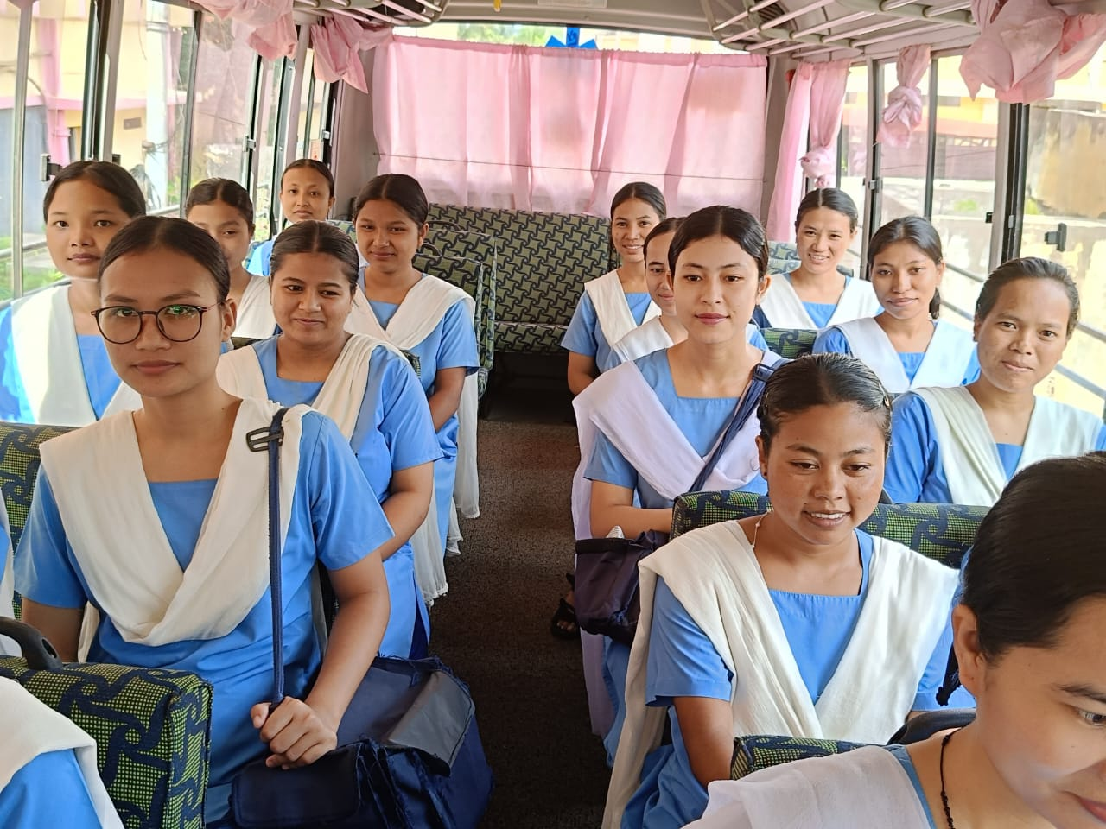

We have school bus for providing safe, reliable and efficient transportation during our academic related journeys. This enhances easy access to essential clinical experiences and community engagements together with promotion of inclusivity and safety. The bus service of the school addresses multiple needs, contributing to a more effective educational environment.